Dawson Kennedy

2-3 Milestone One: Project Proposal

05/15/2024

CS-330-11165-M01 Comp Graphic and Visualization 2024 C-3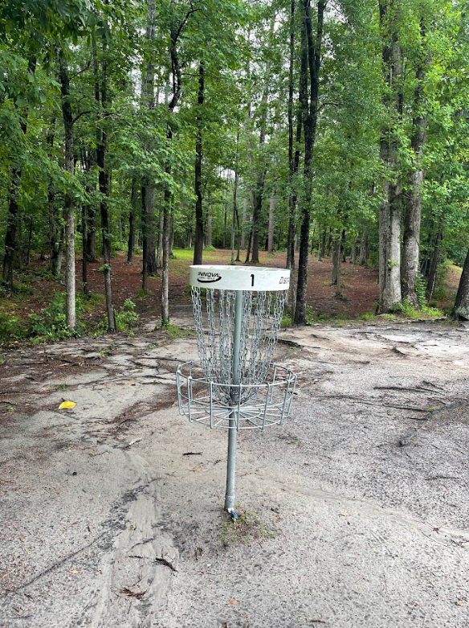

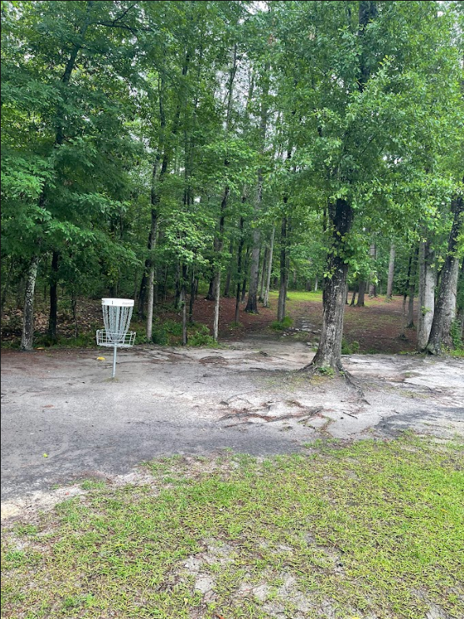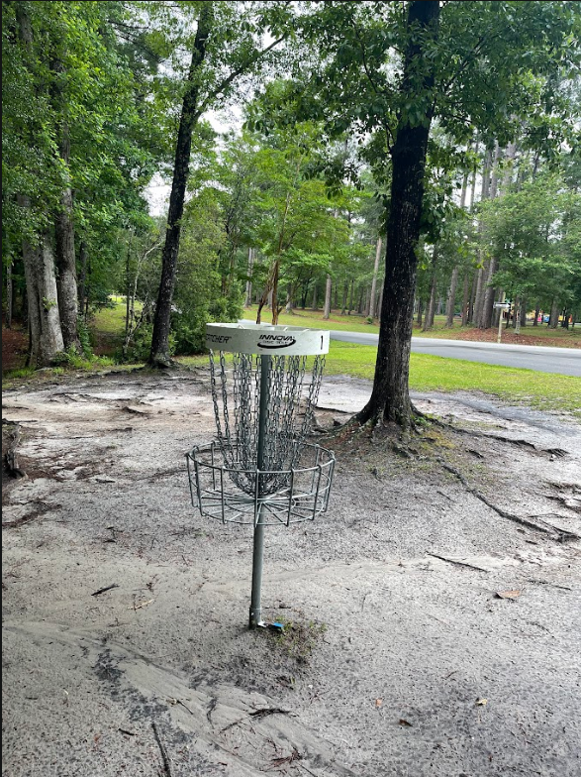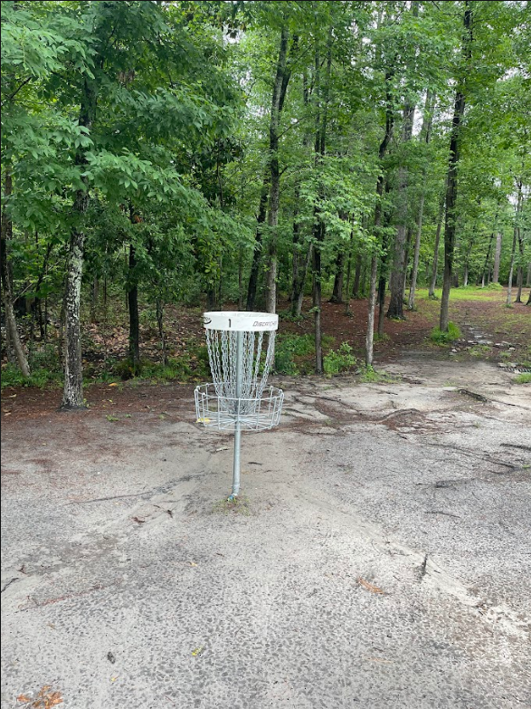

These are the pictures I took from a local disc golf course around where I live that I go to. It is the first basket you get too to start off the course. When thinking of scenes I could do for this project I kept coming back to the idea of a disc golf basket so I went and grabbed a few photos of the first basket. This course specifically because it is close to my house and locally known among disc golfers as “Castle Pain” because of how challenging this course can be. It is super wooded and honestly really pretty to walk through, which is awesome for this project as it gives a lot to be able to model. More specifically what I will model in this scene and some shapes I will. I will model some of the trees, especially the one right next to the basket. I could use a cylinder to model the truck as a majority of these trees are super skinny uniform trunks. For where the leaves are I could use a cone but depending on the tree the cone could be upside down. For the ground it will be a plane, if I can do the dip in the background where the small creek runs through I will. The basket itself will take a few shapes. The pole in the center will be a cylinder, the basket can also be a cylinder just squashed the same as the top but the chains could either be a tapered cylinder or a cone and that is if it don't have to model each individual. If I do it can be a stretched torus and copied all the way around to make the chains.